You are given two linked lists: list1 and list2 of sizes n and m respectively.

Remove list1's nodes from the ath node to the bth node, and put list2 in their place.

The blue edges and nodes in the following figure incidate the result:

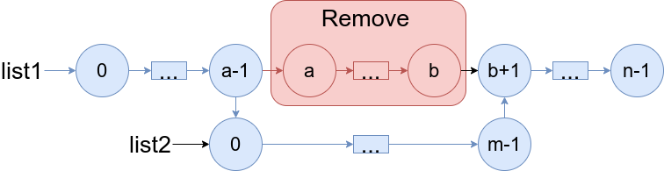

*Build the result list and return its head.*

**Example 1:**

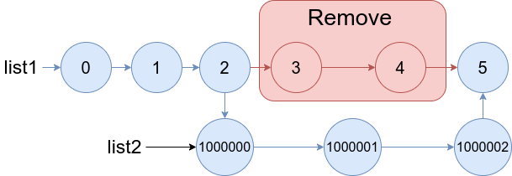

**Input:** list1 = [0,1,2,3,4,5], a = 3, b = 4, list2 = [1000000,1000001,1000002]

**Output:** [0,1,2,1000000,1000001,1000002,5]

**Explanation:** We remove the nodes 3 and 4 and put the entire list2 in their place. The blue edges and nodes in the above figure indicate the result.

**Example 2:**

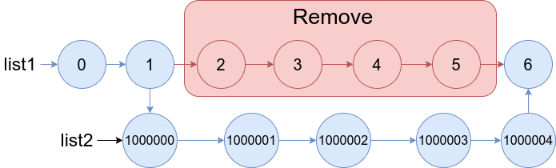

**Input:** list1 = [0,1,2,3,4,5,6], a = 2, b = 5, list2 = [1000000,1000001,1000002,1000003,1000004]

**Output:** [0,1,1000000,1000001,1000002,1000003,1000004,6]

**Explanation:** The blue edges and nodes in the above figure indicate the result.

**Constraints:**

* 3 <= list1.length <= 104
* 1 <= a <= b < list1.length - 1
* 1 <= list2.length <= 104